**STANDARD OPERATING PROCEDURE**

**TITLE:** Submitting AQS Report

**SOP NUMBER:** TAP 11.3.3b

**VERSION:** 1

**PREPARED BY:** **DATE:** 11/03/15

**TITLE:** Administrative Assistant

**REVISED BY:**  **DATE:**

**TITLE:**

**REVIEWED BY:**  **DATE:**

**TITLE:**

**APPROVED BY:** **DATE:**

**TITLE:** Environmental Department Director

# Scope of Application

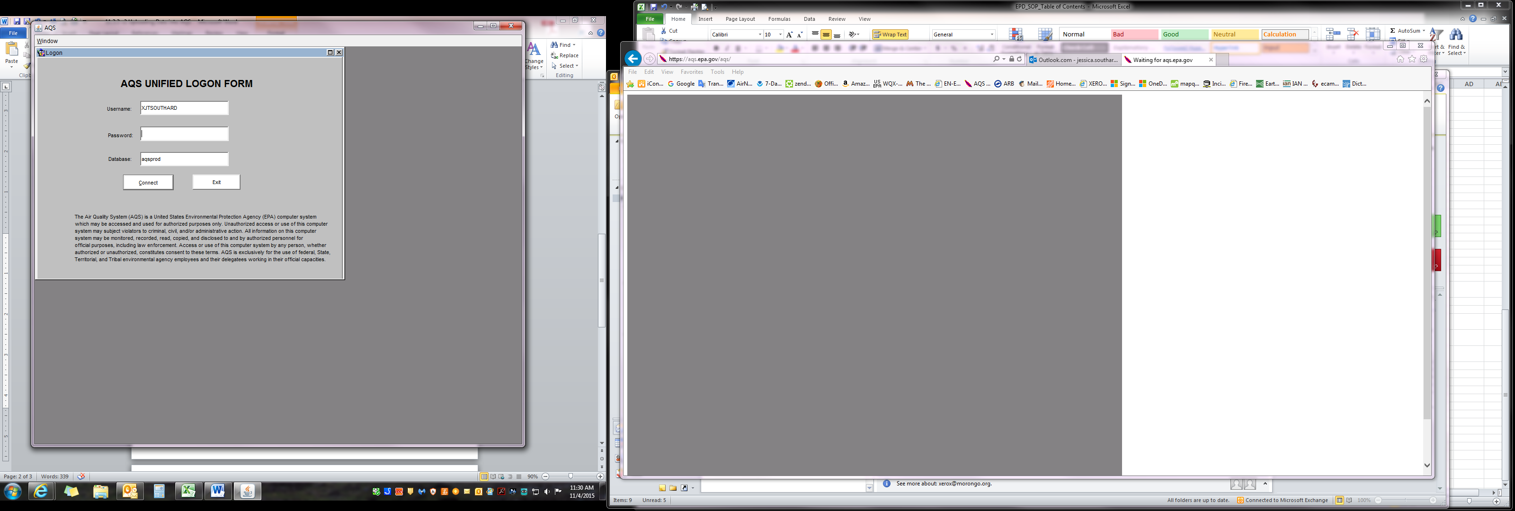

*4.2*

## To ensure data was input correctly, and inform Tribal Air Specialist of Data Submission to AQS.

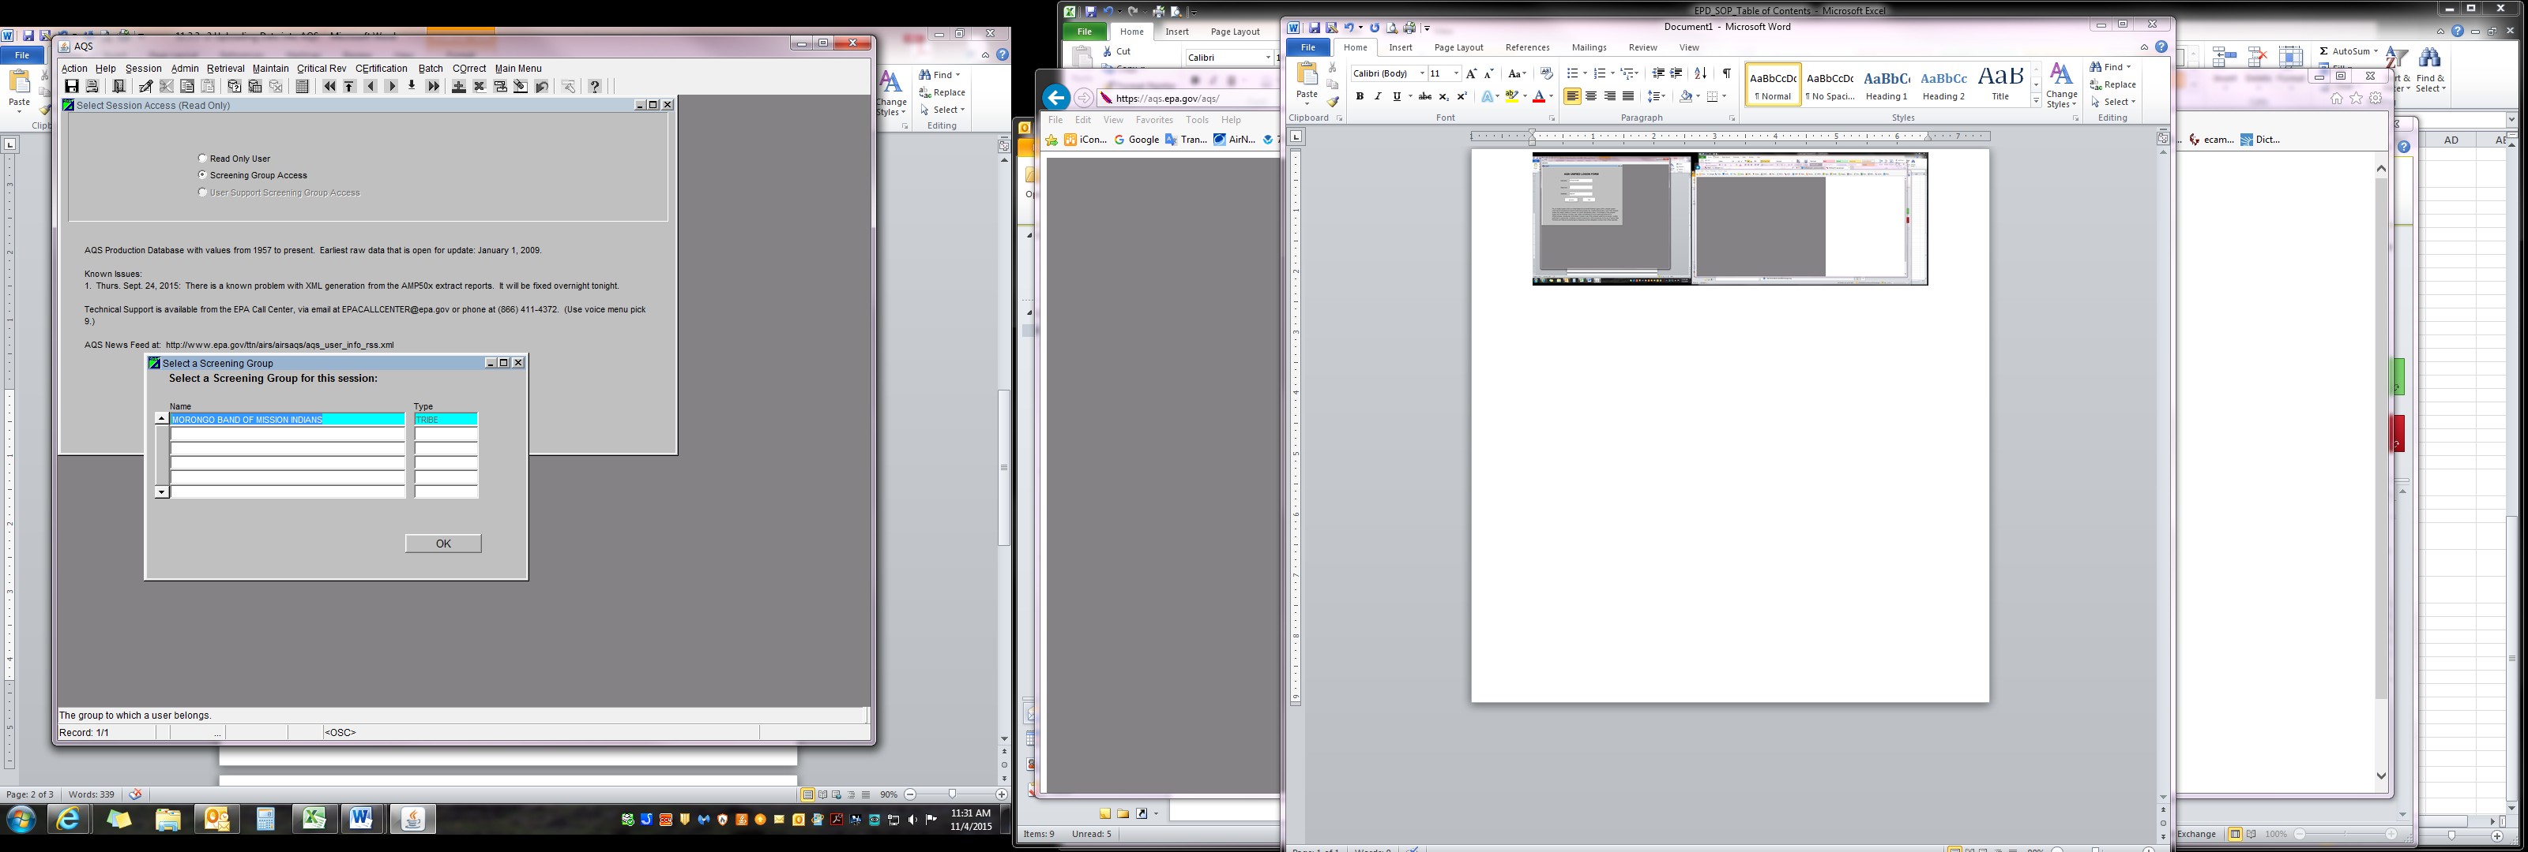

*4.3 & 4.4*

# Supplies

* 1. Access to AQS

# Preparation

## Pollutant data should have been entered into AQS (see SOP 11.3.3 Uploading Data into AQS)

# Procedure

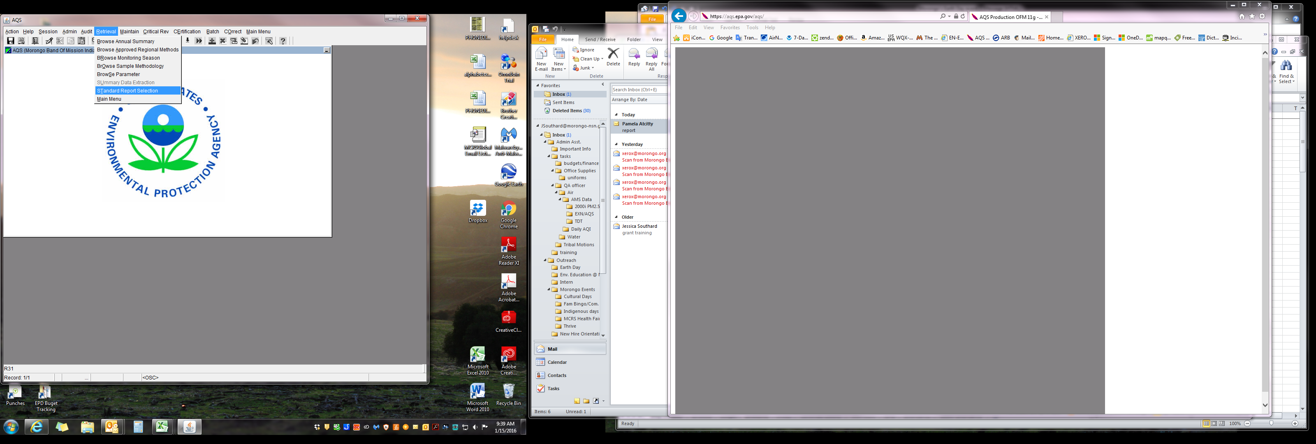

*4.5*

(if already logged in after, skip to step 4.5)

# Access AQS using favorites tab or at www.epa.gov/

# ttn/airs/airsaqs/aqsweb/, select “Proceed to AQS” and select “Agree to terms of AQS”, Run Java Program.

# Sign-in using AQS Login and Password, click connect.

# Select “Screening Group Access”.

* 1. “Select Screening Group” window will appear with Morongo already highlighted, click “OK”.

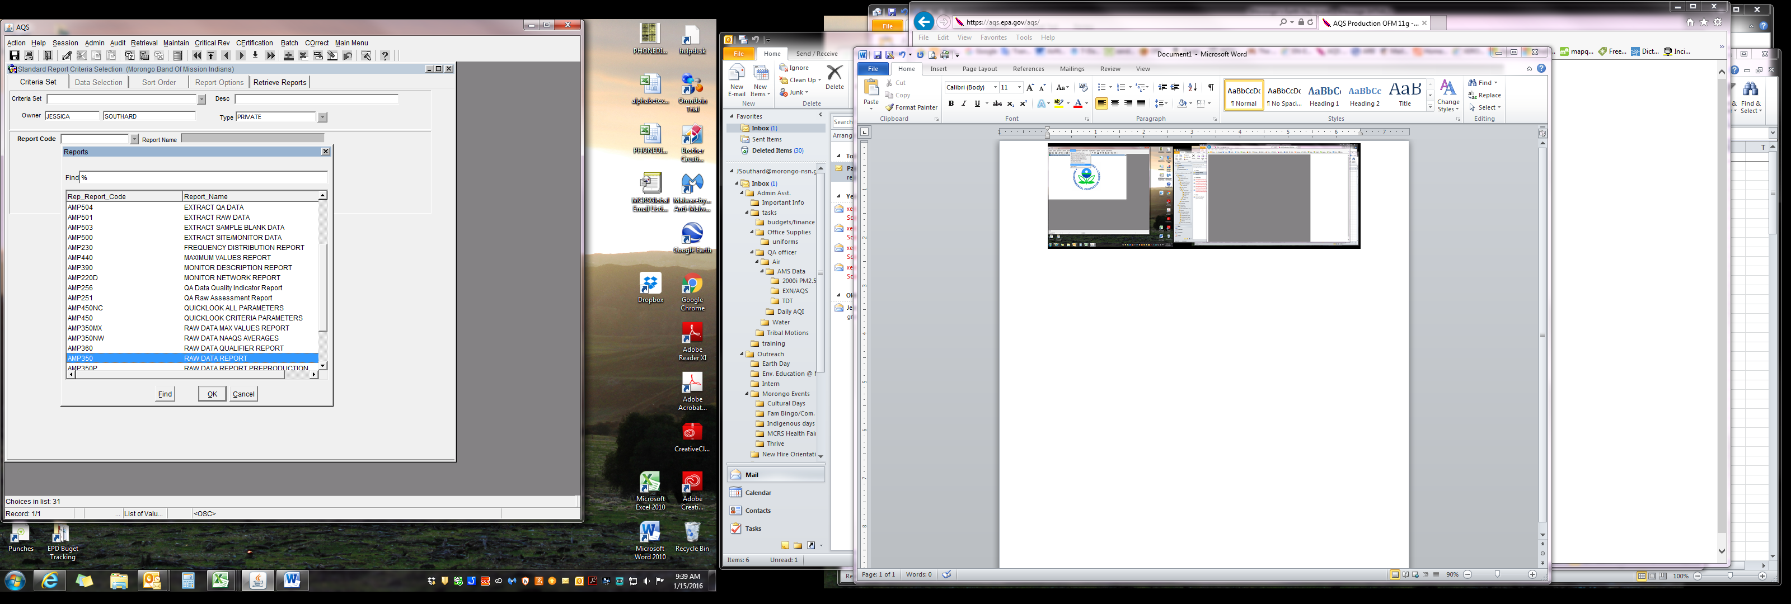

*4.6*

* 1. On the top row of actions, click on “Retrieval”, and select “Standard Report Selection”.
  2. In the “Criteria Set” tab, find “Report Code”, use the drop down to select “AMP350”, then click “OK”.
  3. Click on the “Data Selection” tab. Under the “Criteria Set” tab, enter the following:
     1. *Monitor/Geographic Criteria*

## State Code: 06

## County Code: 065

## Site id: 1016

## Parameter Code: PM 2.5-88101, Ozone-44201, NO2-42602

## POC: 1

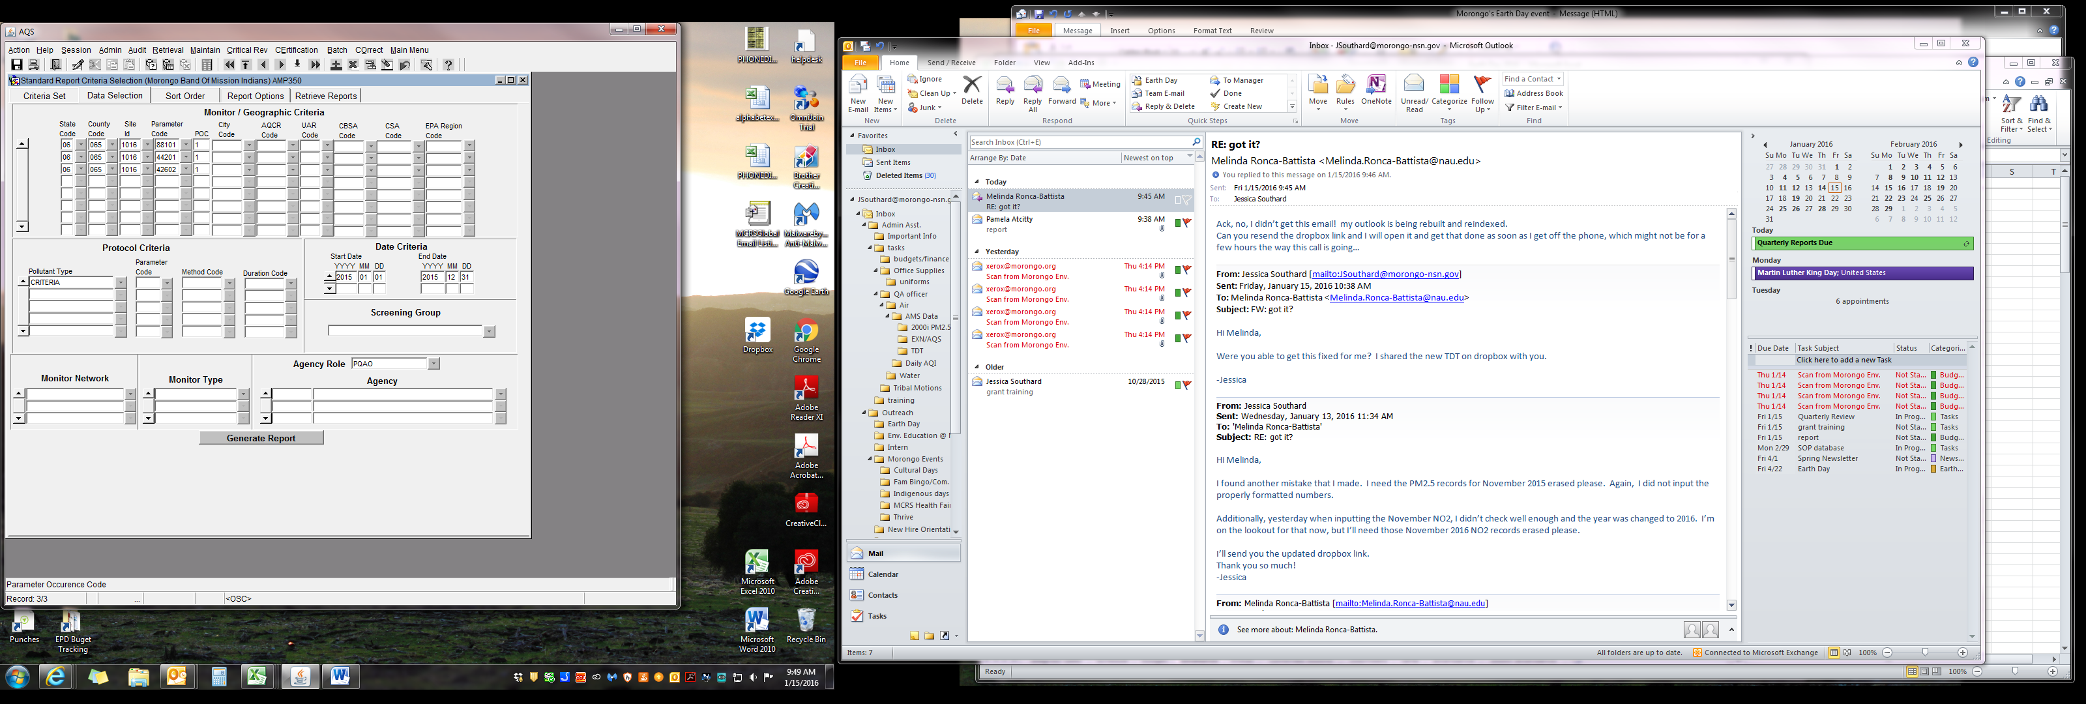

*4.7*

4.7.2 *Date Criteria*

## Start Date: YYYY, MM, DD

## End Date: YYYY, MM, DD

Then click on “Generate Report” (wait while Report generates).

4.8 Report will automatically open when finished. Review, then save the report with “MONYEAR” added to the end of the name, in folder: *O:\Tribal Air Program\DATA\AQS\AQS Reports\YEAR.*

4.9 Email the report to the Tribal Air Specialist.

1. **Troubleshooting**

Contact the EPA Help Center at 1-866-411-4EPA (4372) or refer to the EPA’s website www.epa.g ov/ttn/airs/airsaqs/faq/aqsfaq_loadingdata.htm

